**WORKING PHP WITH MYSQL**

PHP provides a bult-in extension called Mysqli for interacting with MySql database from PHP code

The extension is enabled by ensuring the following line

extension=php_mysqli.dll

The extension provides both an object-oriented and procedural interface for working with MySql

We will be working with the object-oriented interface and utilizing the following provided classes

- MySQLi

- MySQLi_Result

**OPEN – CLOSE CONNECTION**

**OPEN CONNECTION**

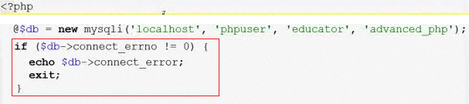

**SQL COMMAND**



**INSERT – SELECT – DELETE – UPDATE**

**CLOSE CONNECTION**

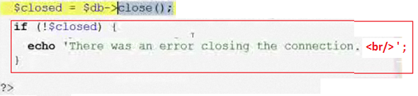

**INSERT**

**OPEN CONNECTION**

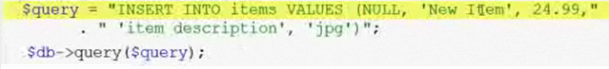

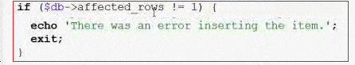



**CLOSE CONNECTION**

**IMPORTANT**: In the INSERT

* If $db->affected_rows is 0 then there was an error
* Once insersed the ID generated is $db->insert_id

When running the output is:



**DELETE / UPDATE**

**OPEN CONNECTION**

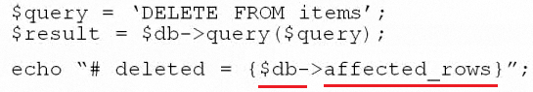

**= = = = = = = = = = = = = = = = = = = = = = = = = = = = = = = =**

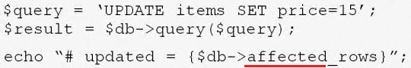

**CLOSE CONNECTION**

**IMPORTANT:** You may include:

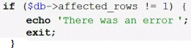

**SELECT**

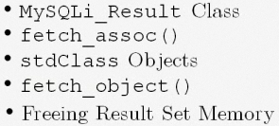

- SELECT queries are run using MySQLi query method and will return a MySQLi_Result object

- The MySQLi_Result class is used to represent result set returned from select queries.

- It has the property num_rows, and has 2 methods:

- **fetch_assoc()** fetch a row of the result set and return it as an associate array

- **fetch_object()** fetch a row of the result set and return it as an object of class stdClass

The 2 fetch methods are used to loop over the rows of a result set and will return NULL if there are no more rows in the result set

1. **FECTH_ASSOC:**

**OPEN CONNECTION**

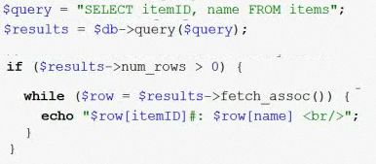

**CLOSE CONNECTION**

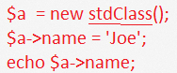

1. **FETCH_OBJECT: (stdClass() )**

**OPEN CONNECTION**

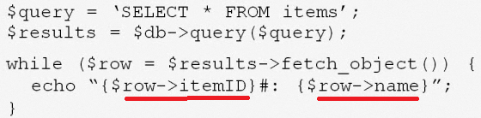

**CLOSE CONNECTION**

**IMPORTANT: AFTER PROCESSING A RESULT SET YOU MUST FREE THE MEMORY**



